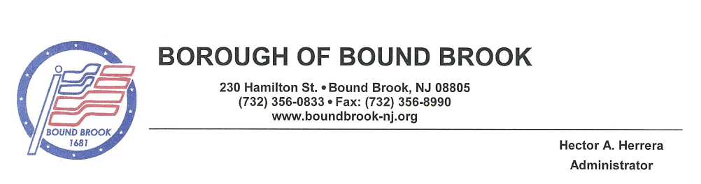
BOROUGH OF BOUND BROOK
PERMIT #__________________
FLEA MARKET GARAGE SALE YARD SALE

As per Ordinance 2022-026, the following application shall be completed by applicant and approved by the Borough of Bound Brook prior to hosting any flea markets, garage sales or yard sales.
Applicant’s Information
Full Name:
Email Address:
Phone Number: Cell Phone:
Address where event is taking place:
Event Date(s): Event Rain Date(s):
- - - - - - - - - - - - - - - - - - - - - - - - - - - - - - - - - - - - - - - - - - - - - - - - - - - - - - - - - - - - - - - - - - - - - - - - - - - - - - - - - - - - - - - - - - - - -
Important Information:
- No more than twelve (12) flea market, garage sales and/or yard sales, in total, will be issued to a residence in one (1) calendar year.
- Residences are limited to one (1) flea market, garage sale and/or yard sale per calendar month or a one-two day weekend.
- The two-day weekend flea market, garage sale and/or yard sale shall be issued one (1) permit per day for a total of two (2) permits for the weekend.
- Each issued permit shall count towards the twelve (12) permits allowed in one (1) calendar year.
- Issued permits shall allow for one (1) rain date.
- Applications for permits for flea markets, garage sales and/or yard sales may be made at the Borough Clerk’s Office and should be requested at least 48 hours prior to the sale.
- The flea market, garage sale and/or yard sale permit must be posted at a visible location to the traveling public for the duration of the sale.
- There will be no more than two (2) signs advertising the flea market, garage sale and/or yard sale. Signs may be posted no more than three (3) days prior to the sale and must be removed within twenty-four (24) hours of the conclusion of the sale. Failure to remove the signs within 24 hours will subject the sale operator to a $10.00 per day penalty.
- Signs may ONLY be in the form of lawn signs. They may NOT be placed on public property, telephone poles, or light poles.
Exemptions
- This chapter will not be applicable to sales by bona fide charitable, educational, cultural or governmental institutions, civic group, service club, religious or fraternal society or other tax exempt organizations; provided, however, that the burden of proof to establish the exemption under this subsection shall be on the organization or institute claiming such exemption.

_____________________________________________________ The fee for this Application is: $10 per day
Signature of Applicant Date Total Payment $
Cash Check

