 | Request for Shade Trees  Bound Brook Shade Tree Commission  230 Hamilton St. Bound Brook, NJ 08805  Phone: (732) 356-0833 shadetree@boundbrook-nj.org | 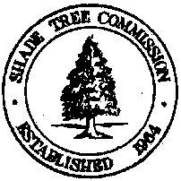

As the legal owner of property abutting a borough street, I hereby request shade tree(s) from the Borough of Bound Brook to be planted in front of my property according to Borough regulations and ordinances in existence at present or as amended in the future.

It is understood that the Shade Tree Commission will fill requests on a first-come, first-served basis, to the extent that funds appropriated for this purpose will permit. If there are more requests than funds available to fill them, the Commission will defer action on the most recent requests until the following year(s).

Shade trees may be planted during the spring or fall, to be determined by the Shade Tree Commission.

Date of Request:

Name (Please Print):

Signature:

Address:

Telephone:

Shade Tree Commission Report

Date Received:

Date Investigated: Commissioner:

Overhead wires? Planting Strip Width:

Recommended Action / Comments:

Date Tree Planted:

